1.Find the M-th maximum number and Nth minimum number in an array and then find the sum and difference of it.

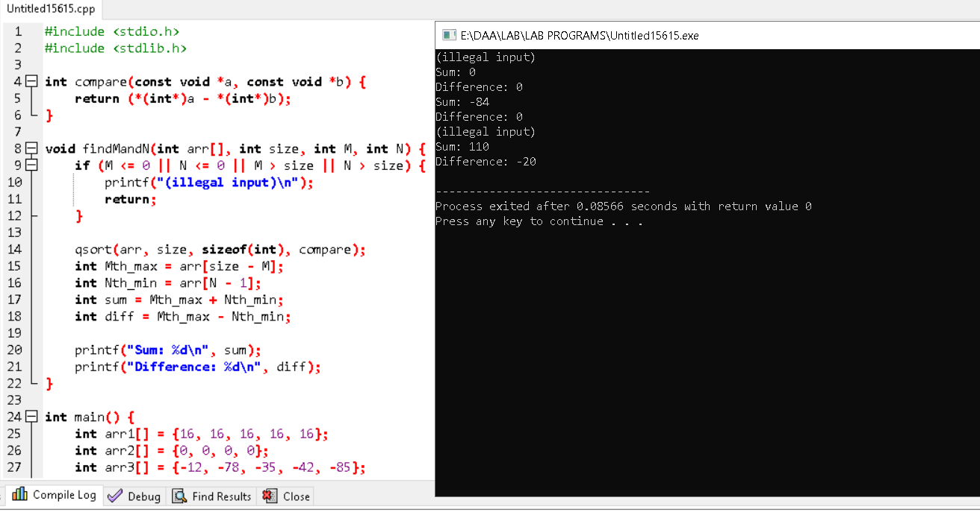

2. Consider a two integer arrays nums1 and nums2, sorted in non-increasing order and two integers m and n, representing the number of elements in nums1 and nums2 respectively. Write a program to Merge them into a single array using Merge Sort. Derive time complexity of merge sort

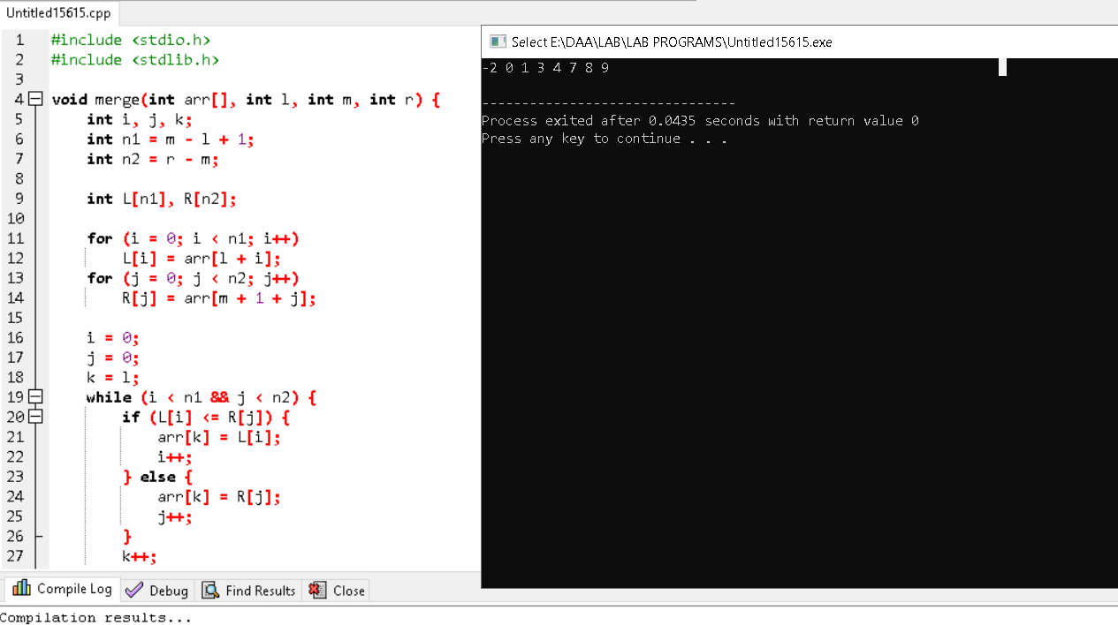

3. Write a program to find the sum of digits. You are given a 0-indexed array nums consisting of positive integers

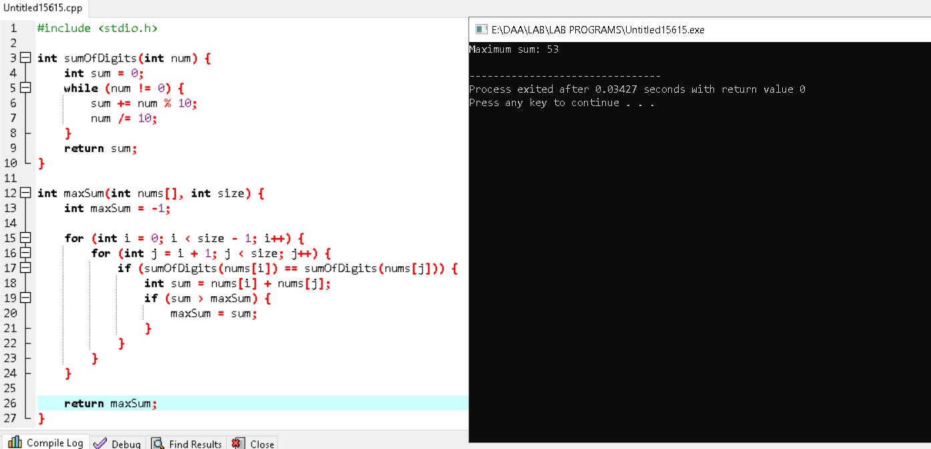

4. Write a program to find all pairs shortest path using Floyd's technique and to estimate its time complexity

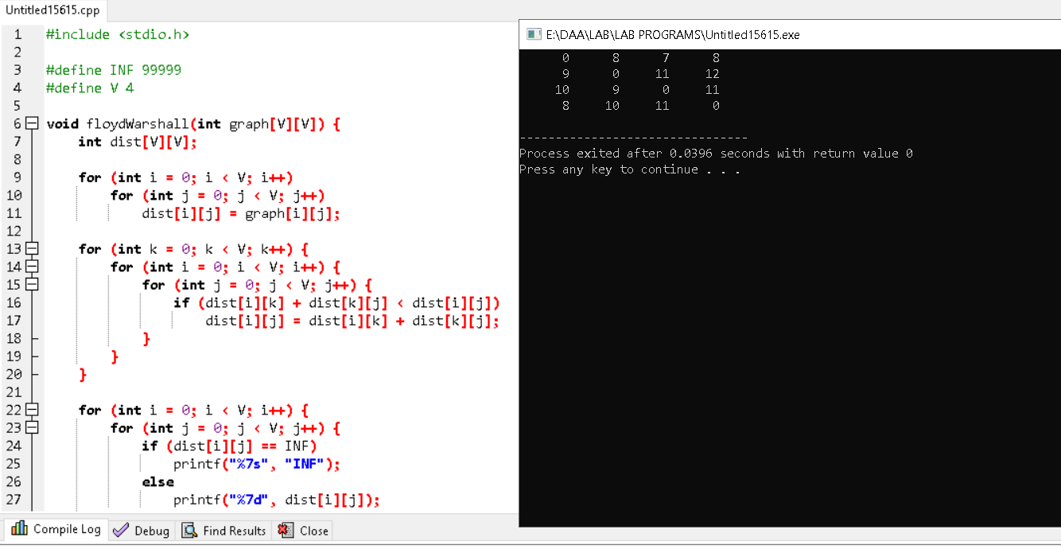

5.Write a program to perform linear search and estimate time complexity. Compute the amount of time for completion.

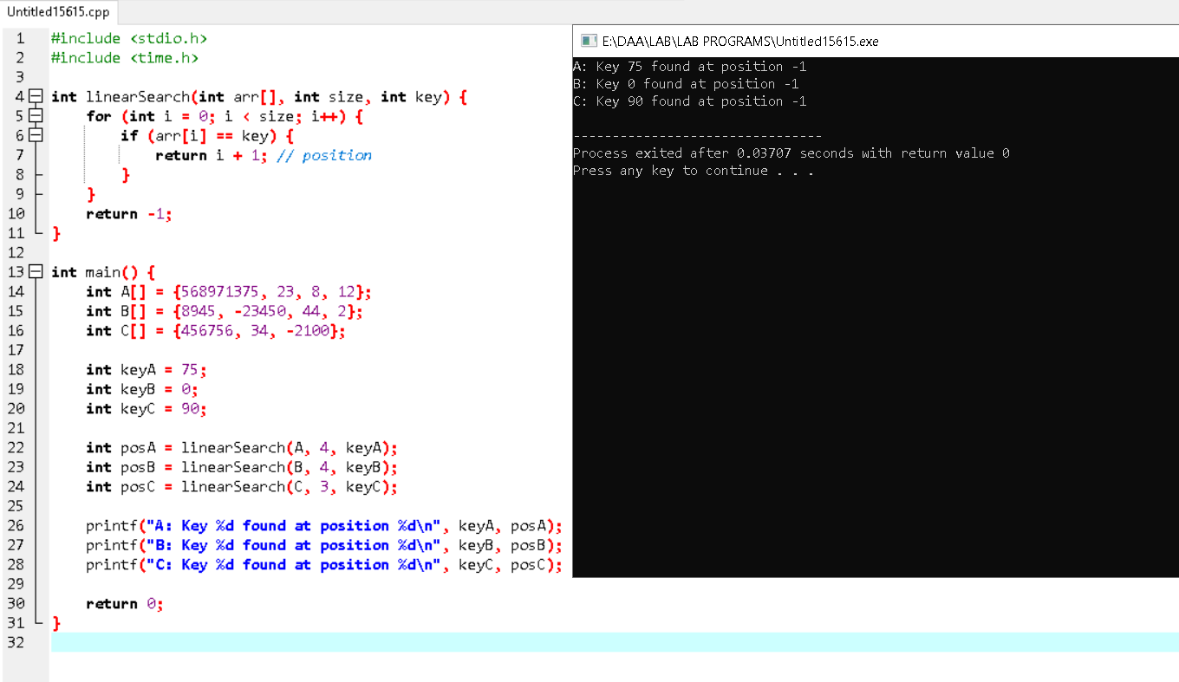

6. Write a program to compute Binomial coefficient for n=8, k=8 using dynamic programming

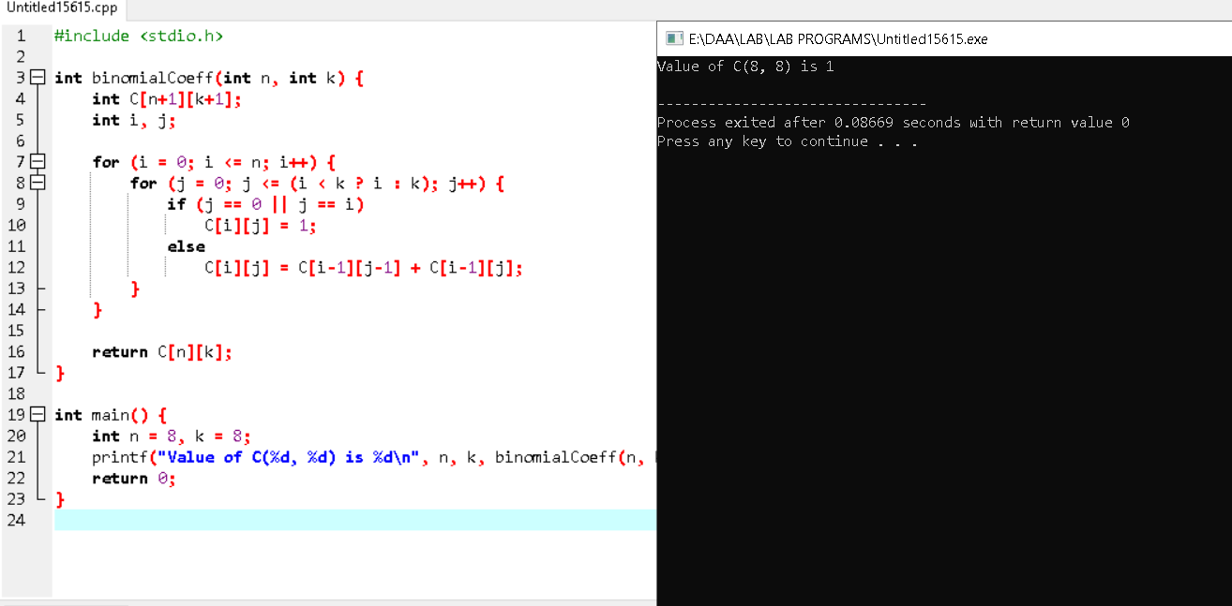

7.Write a program to find the factorial (fact)of a number and to estimate time complexity. Conditions such as i. n=0, return 1 otherwise fact (n-1) * n

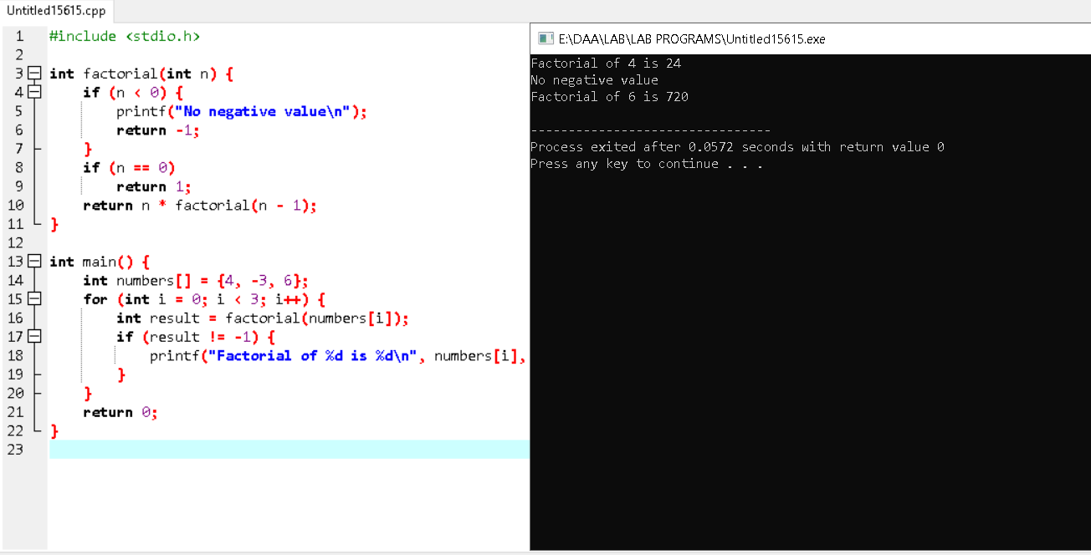

8. Write a program to perform Knapsack problem using greedy approach for the following set of object values.,

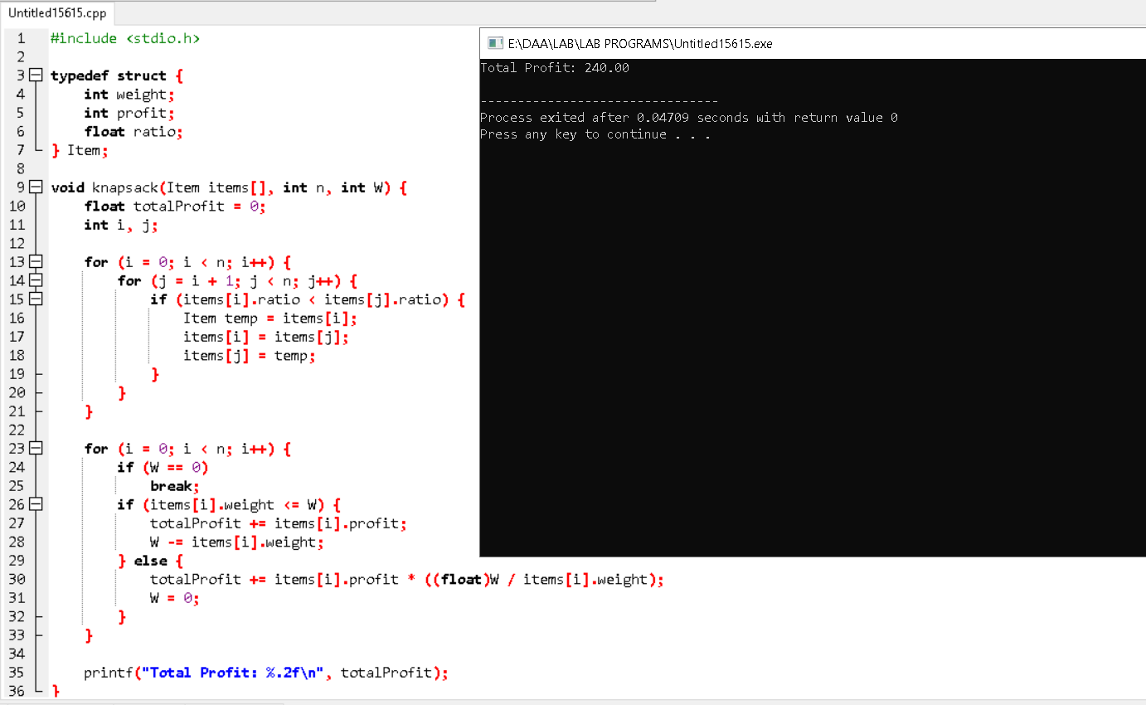

9. Write a [Program to find even Sum of Fibonacci Series Till number N](https://www.geeksforgeeks.org/java-program-to-find-sum-of-fibonacci-series-numbers-of-first-n-even-indexes/)?

Sample Input: n = 4

Sample Output: 33

(N = 4, So here the Fibonacci series will be produced from 0th term till 8th term: 0, 1, 1, 2, 3, 5, 8, 13, 21

Sum of numbers at even indexes = 0 + 1 + 3 + 8 + 21 = 33)

